Chapter 6, Solution 73.

Consider the op amp as shown below:

Let v_{a} = v_{b} = v

At node a, 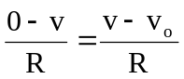 2v - v_{o} = 0 (1)
−
+
R
v
R
R
C
v_{i}

+
−
b
+
v_{o}
−
R
v
a

At node b, 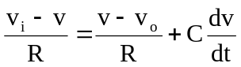
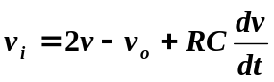 (2)

Combining (1) and (2),

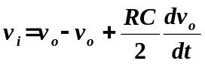
or
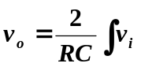dt

showing that the circuit is a noninverting integrator.

